**Biology Revision: Breathing and**

Mastery Matrix Points

|  |
| --- |
| Describe the purpose of cellular respiration, recalling the word & symbol equation for aerobic respiration |
| Explain how the body responds to exercise in terms of heart rate, breathing rate and breath volume |
| Explain when anaerobic respiration occurs in humans and recall the word equation for this process |
| Explain what is meant by the term ‘oxygen debt’ |
| Explain how lactic acid is converted back into glucose following a period of vigorous activity (triple only) |
| Explain anaerobic respiration in yeast, recalling the word equation for this process |
| Describe how this process of anaerobic respiration (fermentation) is used by humans in the manufacturing industry |
| Label the structure and describe the function of the human lungs (including how they are adapted for gaseous exchange) |

Key Knowledge

**Aerobic Respiration** –

Word equation:

Symbol equation:

Happens in:

**Anaerobic Respiration** –

Word equation:

Symbol equation:

Happens when:

**Fermentation -**

Word equation:

Symbol equation:

Happens in:

Uses of fermentation:

**Oxygen debt –**

**Gas exchange -**

Label the lungs:

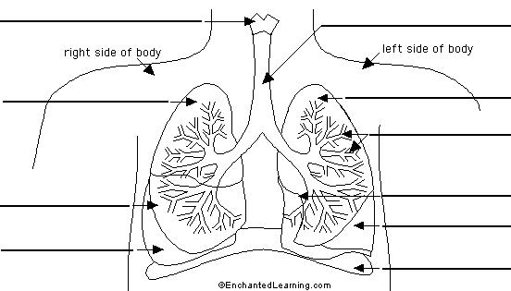

**Respiration**

Understanding and Explaining

1. Describe how these factors change during vigorous exercise: breathing rate, heart rate and breath volume.
2. Explain why these factors change during vigorous exercise: breathing rate, heart rate and breath volume.
3. Explain why anaerobic respiration takes place during vigorous exercise.
4. Explain what happens to the lactic acid produced during vigorous exercise.
5. Compare anaerobic respiration in humans to anaerobic respiration in yeast.
6. Describe the process of gas exchange.
7. Describe and explain how the lungs are adapted for gas exchange.